Service Mesh with ORM stack

Contents

1. Introduction 3
2. Workflow diagram to deploy the stack 3
3. Create stack for Service Mesh 4
4. Plan the Job 5
5. Apply the Job 6
6. Verify in the Console 8
7. Destroy the stack 9

Introduction

Oracle Cloud Infrastructure Service Mesh allows to add a set of capabilities that enables microservices within a cloud native application to communicate with each other in a centrally managed and secure manner. Adding a service mesh is done by deploying a proxy alongside each microservice, which receives configuration information from a managed control plane.

Workflow diagram to deploy the stack

Below diagram shows how the Terraform Artifact are applied in the OCI. While creating a ORM stack, using terraform deliverables Init, Plan and Apply is the flow to provision the resource in the OCI. We can have the deliverables in any of below.

- GitLab/GitHub Repo
- Bitbucket
- Can be in folder/.zip in the local disk
- Object Storage Bucket
- Can be in compartment
- Oracle provided Template

Prerequisite
- Create a Certificate Authority OCID

Create stack for Service Mesh

Go to OCI Console Developer Services Resource Manager Stacks select the compartment Create Stack

My Configuration Folder Browse Select the “Service Mesh” folder that contains the terraform Upload

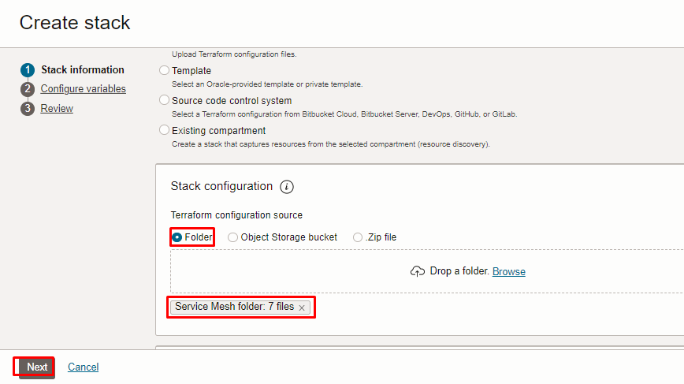

Select the parameters as per the below screen,
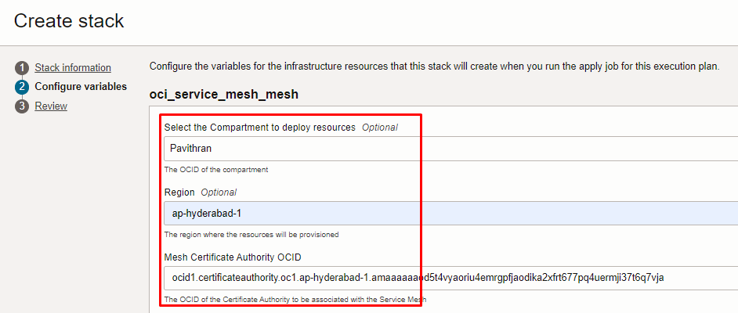
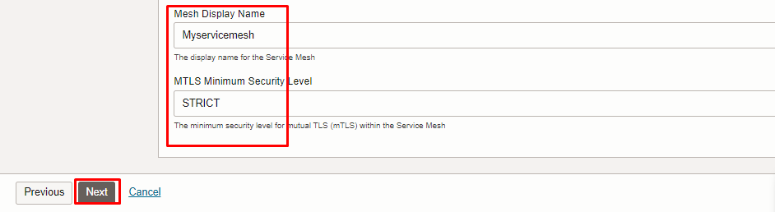
Click “NEXT”

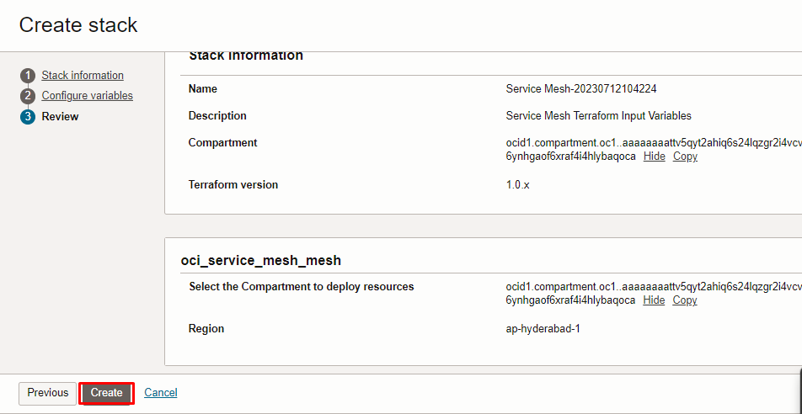
Click “CREATE”

Plan the Job

Click the “Plan”
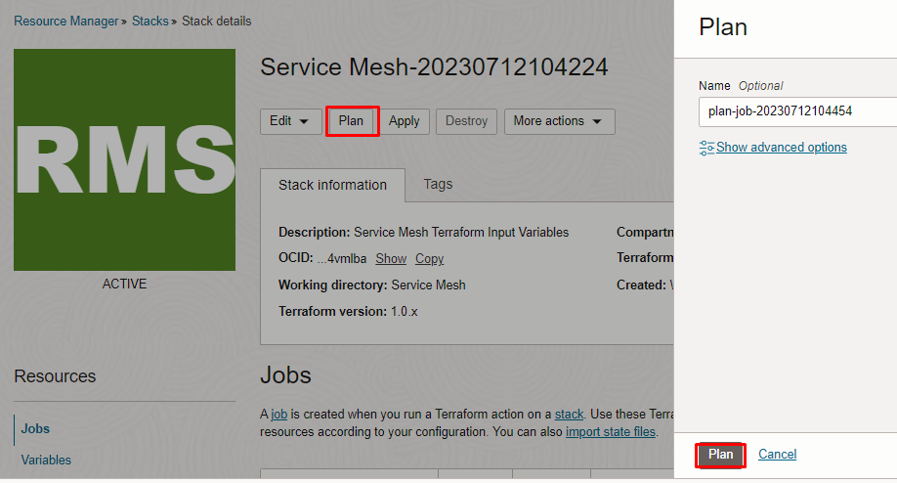
Verify the Plan is successful.

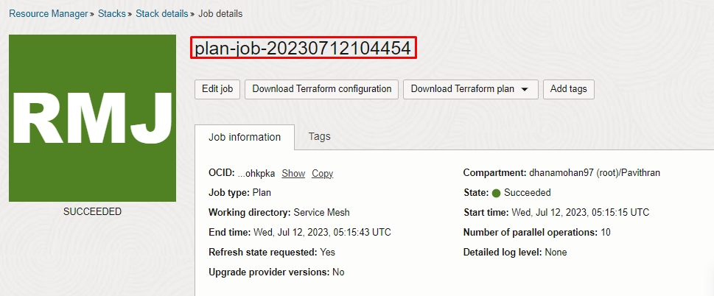

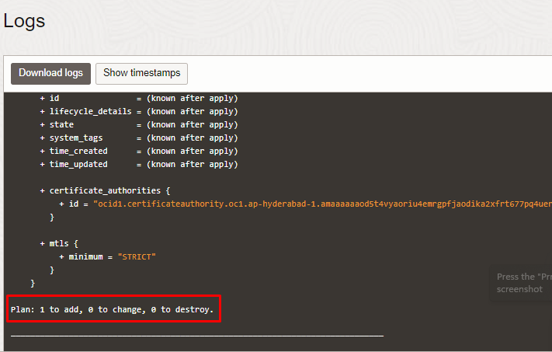

Apply the Job

Once the “plan” is success, now click “Apply”
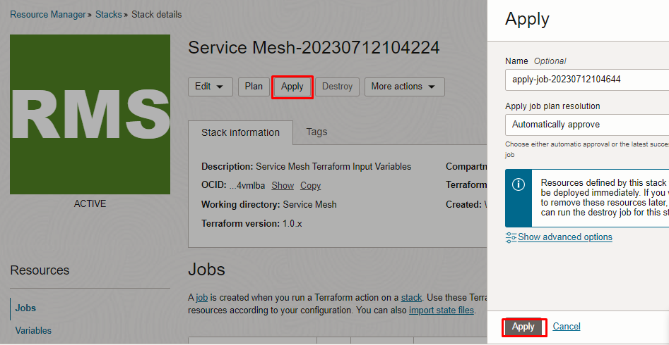

Verify the Apply is successful.

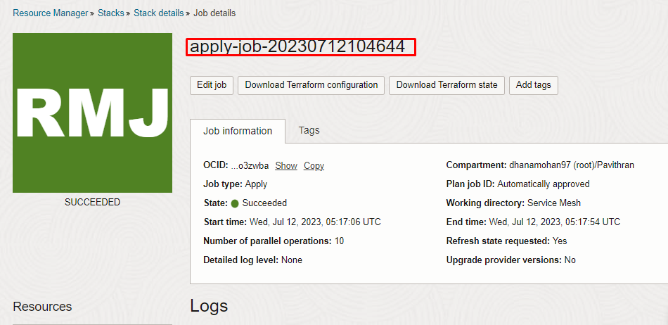
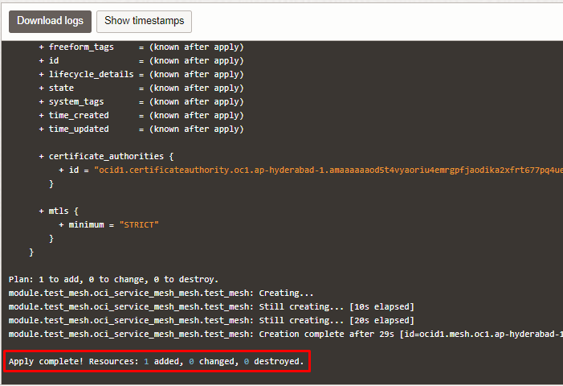

Verify in the Console

Go to OCI Console Developer Services Service Mesh Service Meshes

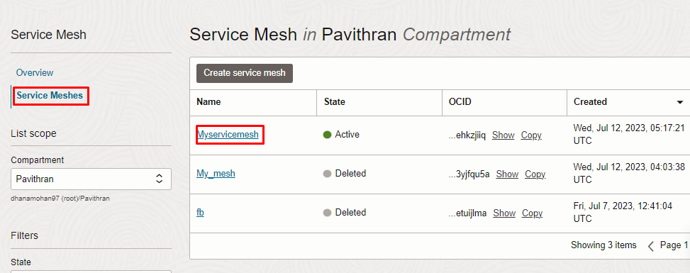

Service Mesh Service Meshes Service Mesh Details

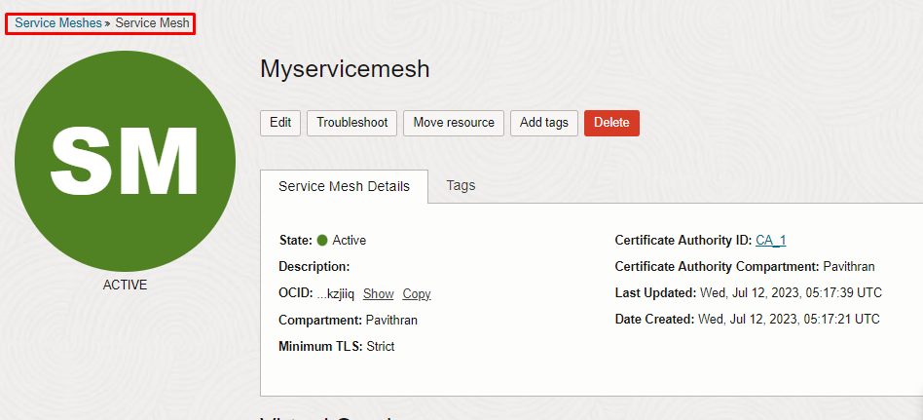

Destroy the stack

Create a destroy job in Resource Manager to release resources associated with a stack and clean up the tenancy. Once destroyed data cannot be recovered from resources.

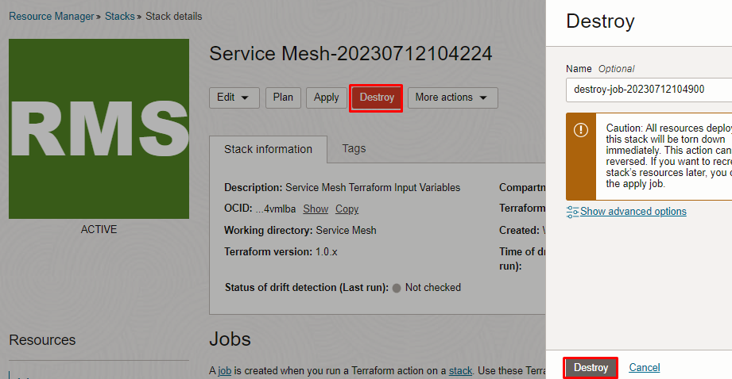

#END#

